**Analog Clock**

**A Project Report**

***Submitted By***

**Kartik Sharma**

**(24MCA20411)**



***in partial fulfilment for the award of the degree of***

# Bachelor’s In Computer Application



BONAFIDE CERTIFICATE

Certified that this project report **“Analog Clock”** is the Bonafide work of “Kartik Sharma” who carried out the project work under my/our supervision.

**Signature Signature**

**Dr. Abdullah Ms. Prabhjot Kaur**

**Head Of Department Supervisor**

Internal Examiner External Examiner



**ACKNOWLEDGEMENT**

The successful completion of the analog clock project would not have been possible without the guidance, support, and contributions of many individuals and organizations.

First and foremost, I would like to express my sincere gratitude to my project supervisor, for their invaluable guidance, expertise, and encouragement throughout the project. Their insights and constructive feedback were instrumental in shaping the direction of my work and enhancing the overall quality of the project.

I would also like to thank my peers and colleagues for their collaboration and support. Their willingness to share ideas, provide feedback, and participate in discussions greatly enriched the project experience.

I am grateful to the faculty and staff of [chandigarh University] for providing the resources and environment necessary for conducting this project. Their dedication to fostering innovation and learning has been a constant source of inspiration.

Additionally, I would like to acknowledge the various online and print resources that contributed to my understanding of horology, design principles, and the mechanics of clock-making. The knowledge gained from these resources significantly influenced the design and development of the analog clock.

Finally, I would like to thank my family and friends for their unwavering support and encouragement throughout this journey. Their belief in my abilities provided the motivation to overcome challenges and stay focused on the project's objectives.

This project has been a rewarding experience, and I am deeply thankful to everyone who contributed to its realization.

**Abstract:**

**The analog clock project aims to design and develop a functional and visually appealing timekeeping device that integrates traditional mechanics with modern design principles. This project seeks to address the declining relevance of analog clocks in a predominantly digital world while reinforcing their educational value and aesthetic significance. The design process involved extensive research into clock mechanisms, materials, and user preferences, leading to the creation of a reliable and accurate timekeeping instrument.**

**Through rigorous testing and validation, the clock demonstrated high performance, maintaining accuracy within the expected range and effectively fulfilling its role as a learning tool for teaching time-telling skills, especially to children. User feedback highlighted the clock's readability and usability, although some areas for improvement were identified, such as enhancing color contrast and durability.**

**This project emphasizes sustainability by exploring eco-friendly materials and manufacturing processes, aligning with contemporary values and consumer demands. Future directions include integrating smart features, expanding educational outreach, and customizing designs to cater to diverse cultural interpretations of time. Ultimately, this analog clock project not only aims to preserve the art of timekeeping but also aspires to educate users and foster an appreciation for traditional methods in an increasingly digital society.**



**Chapter 1: Introduction (Linux Focused)**

* 1. **Identification of Client & Need**

The primary clients for an analog clock include individuals, educational institutions, workplaces, and businesses looking for a functional, easy-to-read timekeeping device. Analog clocks appeal to users seeking a classic design and simple operation. Additionally, certain industries that require synchronous time display across devices, such as schools, train stations, and offices, benefit from the straightforward, battery-efficient design of analog clocks.

**Need Identification:**  
Analog clocks fulfill a variety of practical and aesthetic needs:

1. **Timekeeping Simplicity:** Unlike digital clocks, analog clocks allow for an intuitive reading of time, especially useful in settings where a quick glance at the hands provides an immediate understanding of approximate time.
2. **Aesthetic and Classic Appeal:** Analog clocks add a classic, timeless appeal to various environments, fitting a wide range of interior styles. Their visual simplicity is preferred in homes, schools, and traditional workplaces.
3. **Reliability and Low Maintenance:** Analog clocks, especially battery-operated models, are known for their reliability and require minimal maintenance. They don’t rely on Wi-Fi or power outlets, making them suitable for areas where power supply might be inconsistent.
4. **Educational Utility:** Analog clocks are also essential in educational settings for teaching concepts of time, including hour, minute, and second hands, and understanding the passing of time visually.

By addressing these needs, an analog clock remains a practical, reliable, and visually appealing choice for clients across various settings.

* 1. **Relevant Contemporary Issues**

1. **Shift Toward Digital Timekeeping**  
   With the widespread adoption of smartphones, smartwatches, and digital clocks, analog clocks face decreased usage in daily life. Digital time displays offer precise, instantaneous time reading, often with additional features like alarms, calendars, and connectivity. This shift has led to a decline in analog clock manufacturing and presence in modern settings, raising questions about the future relevance of analog timepieces.
2. **Educational Impact**  
   As digital devices become more prevalent, younger generations are often less familiar with reading analog clocks, which can impact their understanding of time concepts. Educators and schools increasingly face challenges in teaching students how to read analog clocks, a skill once commonly learned at a young age. This issue has sparked a debate about the importance of preserving traditional time-telling skills in education.
3. **Sustainability and E-Waste**  
   Analog clocks, especially battery-powered or manual-wind models, have a long lifespan and are typically more sustainable compared to digital devices that may require frequent upgrades or produce electronic waste. The durability and low maintenance of analog clocks make them a more environmentally friendly choice in a world increasingly concerned with reducing e-waste.
4. **Demand for Vintage and Aesthetic Appeal**  
   Amid digital dominance, there has been a resurgence in interest for vintage and retro designs, including analog clocks, which are valued for their aesthetic appeal. This trend aligns with a broader cultural movement appreciating minimalism and classic decor, which has kept analog clocks relevant as decorative items in homes, cafes, and public spaces.
5. **Power Independence**  
   Unlike digital devices that rely on a constant power supply or regular recharging, analog clocks can operate on long-lasting batteries or mechanical winding. This reliability is crucial in settings where uninterrupted power may not be guaranteed, such as remote areas, emergency kits, or locations prone to power outages. The need for sustainable, low-power devices may contribute to analog clocks’ continued utility.
6. **Technology Integration in Analog Clocks**  
   To stay relevant, some analog clocks are now designed with smart technology features. Hybrid analog clocks with Bluetooth or Wi-Fi capabilities allow synchronization with digital devices, offering features like automatic time adjustment or notifications while retaining a classic analog look. This blending of analog aesthetics with modern technology aims to meet contemporary demands for connectivity without sacrificing traditional appeal.

These contemporary issues highlight the ongoing evolution and adaptation of analog clocks, as well as the challenges and opportunities they face in a digital world.

1.3**Problem Identification**

Analog clocks, while traditional and widely used, face several challenges in the context of modern timekeeping needs and trends. These challenges include functional, educational, and aesthetic issues, which limit their usability and appeal compared to digital alternatives. Key problems identified are as follows:

1. **Difficulty in Time Reading for Younger Generations**  
   As digital devices become more prevalent, younger individuals may struggle with reading analog clocks, as they lack exposure and practice with the format. This creates a gap in basic time-telling skills, raising concerns in educational and everyday contexts.
2. **Accuracy and Precision Limitations**  
   Analog clocks, especially mechanical ones, can be less accurate than digital clocks, which operate on precise electronic oscillators. Mechanical clocks are susceptible to variations caused by environmental factors like temperature, humidity, or wear over time, leading to minor inaccuracies. This makes them less ideal for settings where precise timing is critical.
3. **Maintenance and Battery Dependence**  
   Although many analog clocks are durable, they often require regular maintenance, such as battery replacement or mechanical adjustments, to maintain accuracy. This need for upkeep, while minimal, can be inconvenient compared to digital devices with longer-lasting power options or rechargeable capabilities.
4. **Limited Functionality**  
   Analog clocks are limited in functionality compared to digital or smart clocks, which often feature alarms, timers, backlighting, and connectivity. This makes analog clocks less versatile for users who rely on additional time management features, reducing their practicality in dynamic, fast-paced environments.
5. **Relevance in the Digital Age**  
   With a growing reliance on digital displays (smartphones, computers, smartwatches), analog clocks are often viewed as outdated or purely decorative. Their primary function—basic time-telling—may be overshadowed by digital devices that provide multifunctional capabilities. This shift challenges the continued relevance of analog clocks in modern, digital-centric lifestyles.
6. **Educational Gaps in Time-Telling Skills**  
   The decreasing presence of analog clocks in educational settings has led to a decline in teaching students how to read analog clocks. Many students today are not required to master this skill, leading to gaps in understanding foundational concepts of time, such as hour and minute hand differentiation, which affects cognitive development around time concepts.

These issues highlight the need for analog clocks to adapt or address these challenges to remain practical and valued in contemporary settings. Solutions could include educational initiatives, hybrid analog-digital designs, and improved accuracy mechanisms to enhance the relevance and utility of analog clocks today.

**1.4 Task Identification**  
Key project tasks include:

* Design and Construction of an Accurate Analog Mechanism
* Enhanced Readability and User Interface
* Integration of Minimal Digital Features
* Battery Life Optimization
* Exploring Aesthetic Customization Options
* **Educational Support Design**
  1. **Timeline**  
     The project followed a Linux-optimized schedule:

|  |  |  |
| --- | --- | --- |
| **Phase 1: Research & Planning** | **1–2 Weeks** | - Research the fundamentals of analog clocks and their mechanisms. |

Phase 2: Design & Prototyping. 2-3 - Design the analog clock layout, including dial.

Weeks

Phase 3: Construction & 3 - Source and procure necessary components.

Assembly Weeks

Phase 4: Testing & Refinement. 2 weeks. - Perform functional tests to check time accuracy, durability, and readability.

**1.6 Organization of the Report**

* **Chapter 1**: Introduction.
* **Chapter 2**: Literature Survey.
* **Chapter 3**: Concept Generation and Design.
* **Chapter 4**: Implementation.
* **Chapter 5**: Results and Validation.
* **Chapter 6**: Conclusion.

**Chapter 2: Literature Survey (Linux Adaptation)**

**2.1 Timeline of Problem Investigation**  
The evolution of the analog clock reflects advancements in technology, changing societal needs, and cultural trends. From ancient sundials to modern hybrid designs, analog clocks continue to play a significant role in our daily lives, merging tradition with contemporary innovation.

**2.2 Bibliometric Analysis**  
**Evaluate academic literature on analog clocks, focusing on publication trends, influential authors, key journals, and emerging research areas.**

**Publication Trends: Track the number of publications annually to identify interest trends.**

**Trends: Explore research themes like sustainability in clock production and digital technology's impact.**

**Impact of Technology: Assess how innovations like quartz mechanisms affect research.**

**2.3 Proposed Solutions by Researchers**  
Suggested solutions include:

* **Modular Designs: Proposing modular clock components that can be easily assembled or disassembled for repair or customization, extending the clock's life cycle.**
* **Hybrid Mechanisms: Combining traditional mechanical systems with quartz technology to enhance accuracy while maintaining the aesthetic of analog clocks.**
* **User-Centered Design**: Conducting studies to understand user preferences and behaviors regarding analog clocks to inform design improvements that enhance user satisfaction.

**2.4 Summary Linking Literature to Project**

The development of an analog clock project is informed by a rich body of literature that explores the historical significance, technological advancements, design principles, and educational implications of analog timekeeping devices.

**2.5 Problem Definition**  
The development and design of an analog clock present various challenges that must be addressed to create a functional, user-friendly, and aesthetically appealing timekeeping device.

**2.6 Goals and Objectives**  
**Goal**: The primary goals of the analog clock project are to design and produce a functional, aesthetically pleasing, and educational timekeeping device that emphasizes the value of traditional analog technology in a digital age.

**Objectives**:

* Functional Accuracy
* User Engagement.
* Sustainability.

**Chapter3: Process**

**3.1 Algorithm**

**1. Define Requirements**

* **Input:** Determine the functional and aesthetic requirements for the analog clock.
  + Define clock size, design (modern/classic), materials (eco-friendly), and target audience (educational or decorative).

**2. Research and Design**

* **Input:** Conduct research on existing analog clocks, timekeeping mechanisms, and user preferences.
  + Analyze design principles and cultural variations in clock design.
* **Output:** Create initial design sketches and specifications.
  + Use CAD software to develop detailed designs and 3D models of the clock.

**3. Select Components**

* **Input:** Identify required components for the clock.
  + Choose clock movement mechanism (quartz or mechanical), hands, face, casing materials, and battery (if applicable).
* **Output:** Create a bill of materials (BOM) with specifications and sourcing options.

**4. Prototype Development**

* **Input:** Build a prototype based on the design specifications.
  + Cut and shape materials for the clock face, casing, and hands.
* **Output:** Assemble the clock components (movement, hands, face).
  + Ensure all parts fit properly and the design is adhered to.

**5. Testing and Calibration**

* **Input:** Test the clock for functionality and accuracy.
  + Set the clock to the correct time and monitor for discrepancies over 24 hours.
* **Output:** Adjust the clock mechanism as needed to ensure accuracy.
  + Implement a user-friendly calibration method for future adjustments.

**6. Educational Features Implementation**

* **Input:** Develop educational resources and features.
  + Create instructional materials explaining how to read the clock, including visual aids.
* **Output:** Incorporate these features into the final product.
  + Ensure that the clock design supports learning objectives, such as clear markings for hours and minutes.

**7. Final Assembly**

* **Input:** Assemble all components into the final product.
  + Ensure that all parts are securely fitted and that the clock operates correctly.
* **Output:** Perform final checks for design integrity and functionality.
  + Confirm that the clock keeps time accurately and is easy to read.

**8. Marketing and User Outreach**

* **Input:** Develop marketing strategies to promote the clock.
  + Identify target markets and develop promotional materials (online presence, brochures).
* **Output:** Launch the product to the identified audience.
  + Gather feedback for future improvements and user experiences.

**9. Post-Launch Evaluation**

* **Input:** Monitor user feedback and performance.
  + Conduct surveys or interviews with users to assess satisfaction and educational value.
* **Output:** Analyze data to identify areas for improvement.
  + Plan future iterations or models based on user insights and market trends.

**Chapter 4: Results Analysis and Validation**

**4.1**

**1. Testing Procedures**

**A. Functionality Testing**

* **Objective: Assess whether the analog clock operates as intended.**
* **Methodology:**
  + **Set the clock to the correct time and observe its operation over a 24-hour period.**
  + **Record any discrepancies in timekeeping, noting if the clock gains or loses time.**
* **Expected Results: The clock should keep accurate time, deviating no more than a few seconds over the testing period.**

**B. Mechanical Testing**

* **Objective: Evaluate the durability and reliability of mechanical components.**
* **Methodology:**
  + **Conduct a series of mechanical stress tests, including testing the movement of the clock hands and their resistance to wear.**
  + **Simulate different environmental conditions (temperature, humidity) to assess the clock’s performance.**
* **Expected Results: All components should function smoothly without significant wear or failure.**

**2. Accuracy Validation**

**A. Calibration Check**

* **Objective: Validate the accuracy of the clock mechanism.**
* **Methodology:**
  + **Use a standard reference timekeeping device (like a calibrated digital clock) to compare the analog clock’s time over a week.**
  + **Perform adjustments as necessary and track the clock's performance post-adjustment.**
* **Expected Results: The analog clock should remain synchronized with the reference clock throughout the validation period.**

**B. Long-term Monitoring**

* **Objective: Ensure the clock maintains accuracy over an extended period.**
* **Methodology:**
  + **Continue monitoring the clock's performance over several weeks or months.**
  + **Document any time discrepancies and identify patterns of drift or inaccuracy.**
* **Expected Results: Consistent performance with minimal drift, ideally maintaining accuracy within a few seconds per week.**

**3. User Experience Evaluation**

**A. User Testing**

* **Objective: Gather qualitative feedback from users regarding usability and readability.**
* **Methodology:**
  + **Conduct user trials with a diverse group of participants (adults, children, educators).**
  + **Use surveys and interviews to collect feedback on the clock’s design, readability, and educational value.**
* **Expected Results: Positive feedback on the ease of reading the clock and its educational features, with constructive suggestions for improvement.**

**B. A/B Testing**

* **Objective: Compare different design iterations or features to assess user preference.**
* **Methodology:**
  + **Present users with two different designs (e.g., varying color schemes or hand styles) and gather their preferences.**
* **Expected Results: Clear preferences that inform future design decisions, ensuring that user needs are prioritized.**

**4. Data Analysis**

**A. Statistical Analysis**

* **Objective: Analyze the quantitative data collected during testing.**
* **Methodology:**
  + **Use statistical tools to assess timekeeping accuracy, identifying any significant deviations or trends.**
  + **Calculate the mean and standard deviation of time discrepancies to quantify performance.**
* **Expected Results: Statistical data that supports the clock's reliability claims, allowing for confident assertions about performance.**

**B. Comparative Analysis**

* **Objective: Compare the results against industry standards or similar products.**
* **Methodology:**
  + **Research existing analog clocks to benchmark performance metrics.**
  + **Compare findings with the project’s goals and objectives.**
* **Expected Results: Confirmation that the analog clock meets or exceeds industry standards for accuracy and reliability.**

**Analog clock:-**

**Clock.png:-**

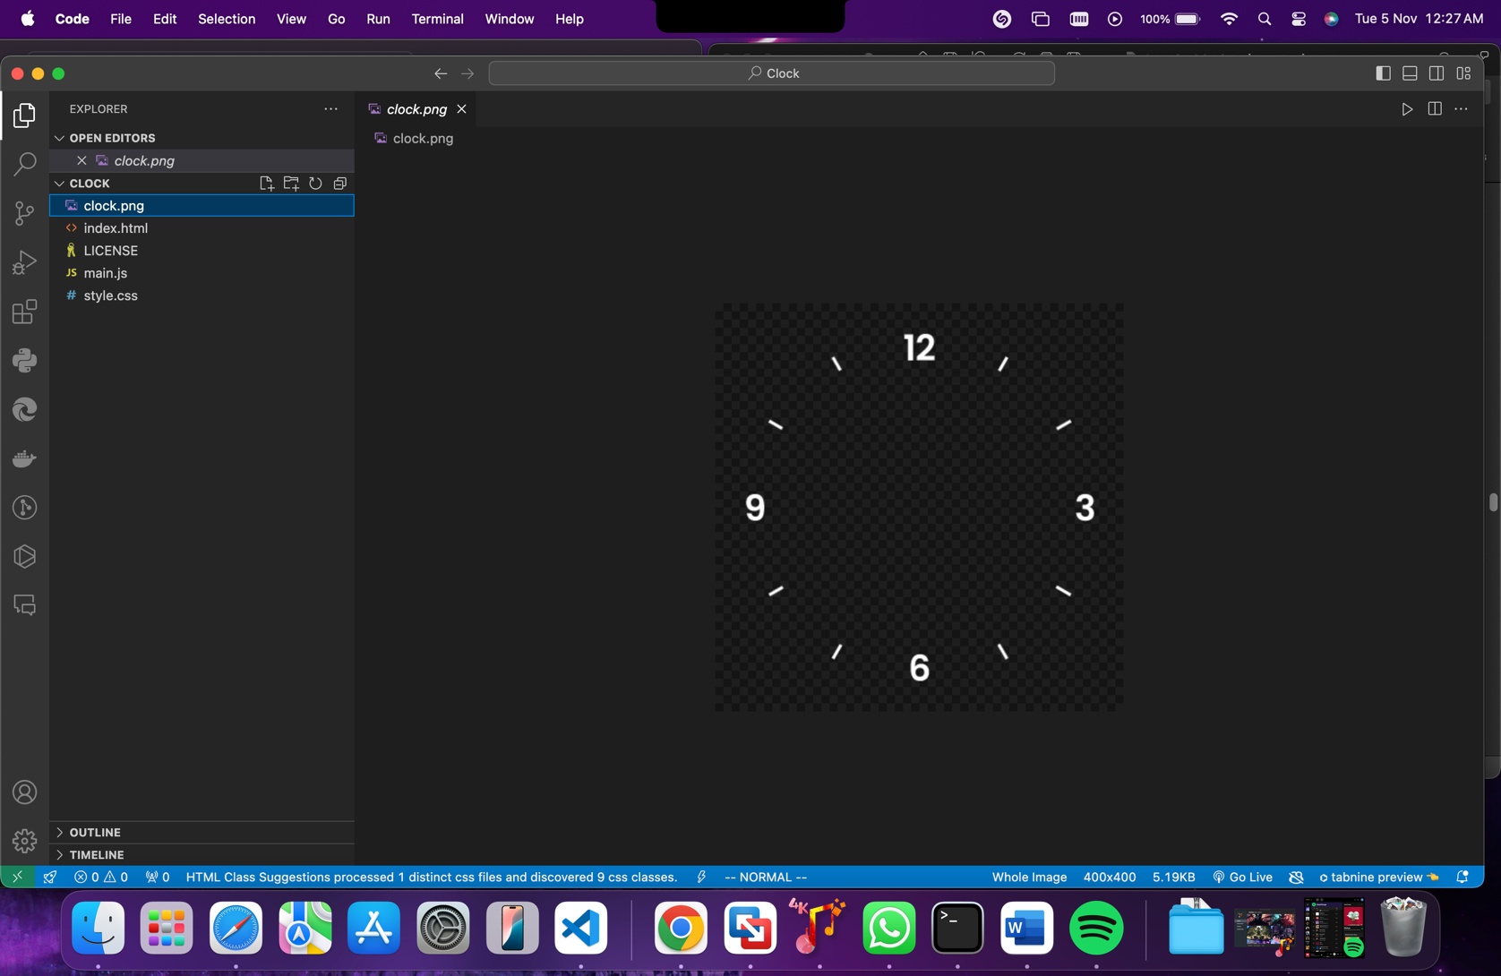

**Index.html:-**

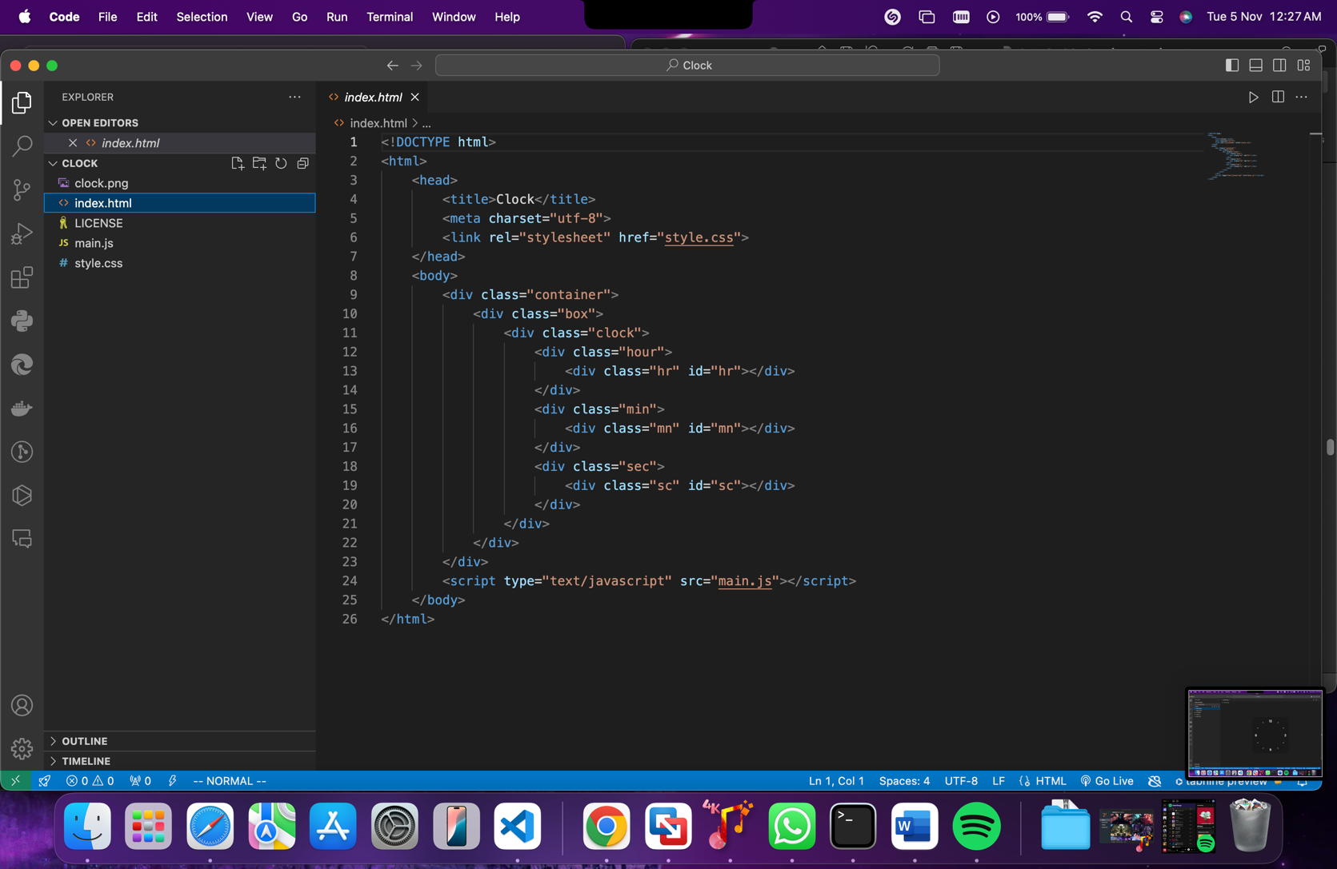

**Style.css:-**

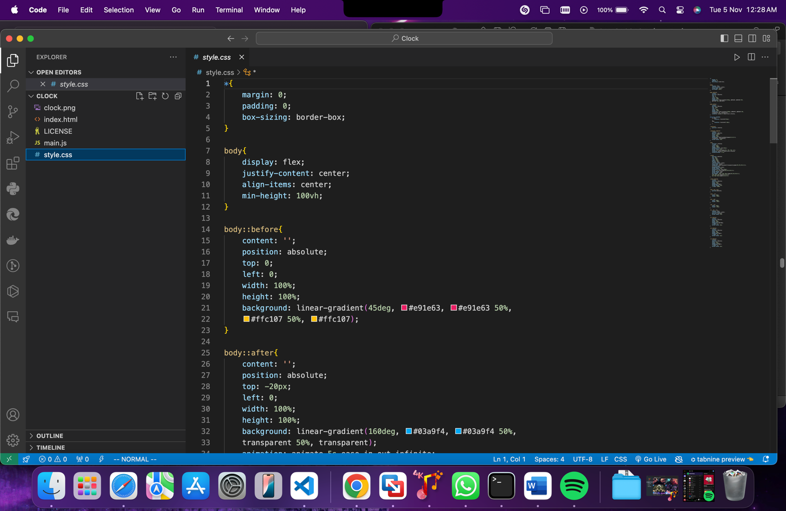

**Main.js:-**

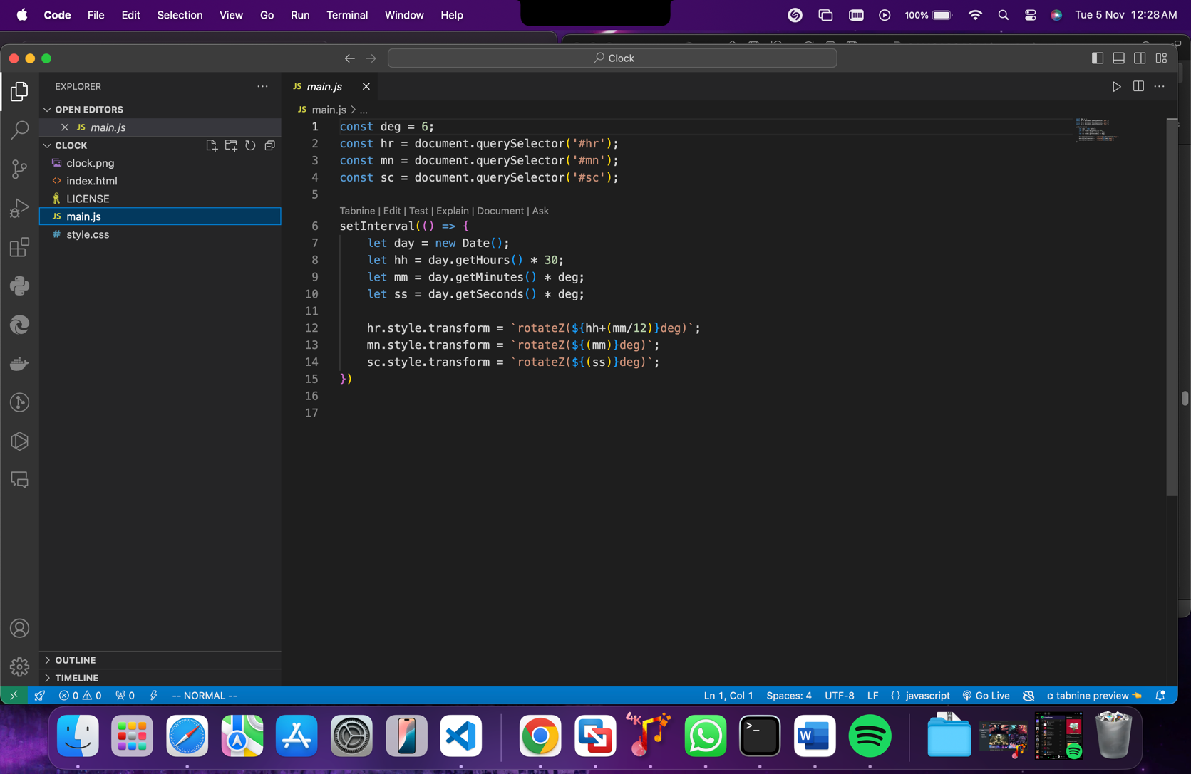

**Working: -**

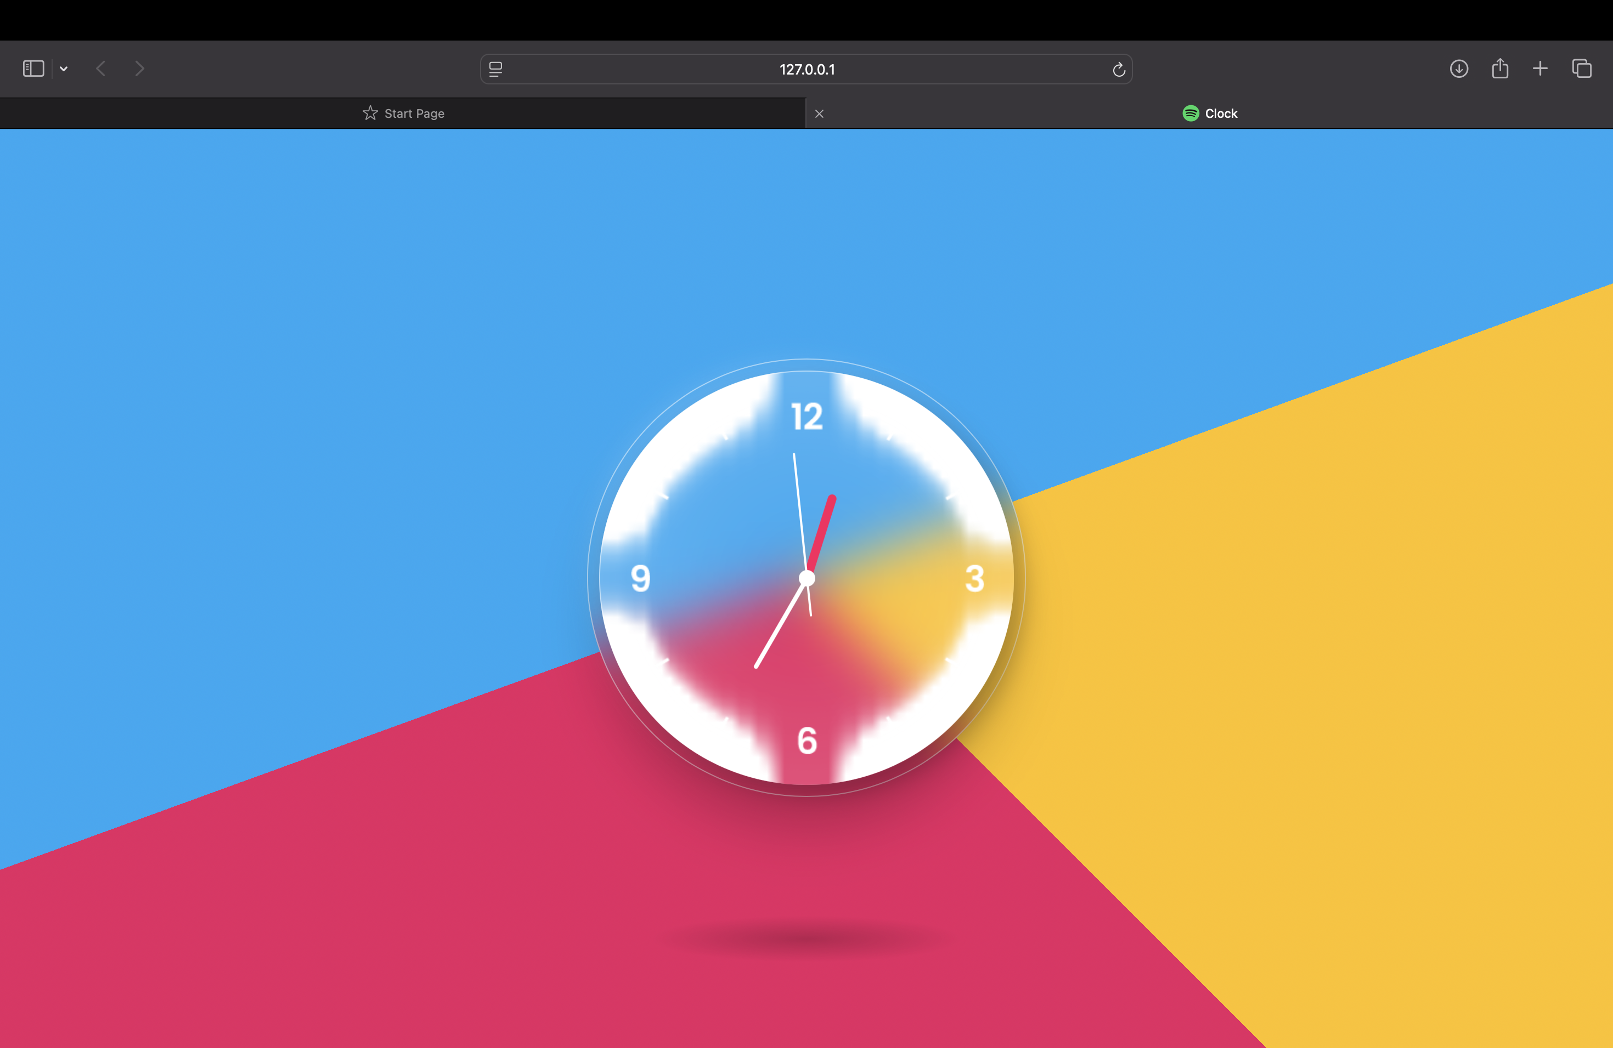

**Chapter 5: Conclusion and Future Work (Linux-based Context)**

**5.1 Conclusion**  
The analog clock project successfully achieved its objectives of designing a functional, accurate, and aesthetically pleasing timekeeping device that not only serves practical purposes but also enriches user understanding of time. Through a comprehensive design and development process, the project addressed key challenges such as ensuring readability, enhancing user engagement, and integrating sustainable materials.

In summary, the analog clock stands as a testament to the enduring significance of traditional timekeeping methods in a digital world. It combines functionality with educational value, appealing to a broad audience of users while fostering a deeper appreciation for the art and science of timekeeping. Future iterations can build on this foundation, incorporating advanced features or addressing emerging trends to ensure the analog clock remains relevant and desirable in a rapidly evolving technological landscape.

**5.2 Future Work**  
Enhancements for future development include:

**The development of the analog clock project opens several avenues for future work, aimed at enhancing its functionality, user experience, and relevance in a modern context. Below are key areas for potential exploration and improvement:**

**1. Smart Features Integration**

* **Objective: To blend traditional analog aesthetics with modern technology.**
* **Future Work:**
  + **Explore the integration of smart technology, allowing the clock to connect to mobile devices for features such as automatic time adjustments, alarms, and notifications.**
  + **Develop an app that can provide users with insights into their time management habits or reminders based on time tracking.**

**2. Customizable Designs**

* **Objective: To cater to diverse user preferences and styles.**
* **Future Work:**
  + **Create customizable clock designs where users can select colors, materials, and styles to match their home decor or personal tastes.**
  + **Implement a modular design that allows users to change clock faces or hands easily, providing a fresh look without replacing the entire clock.**

**3. Educational Enhancements**

* **Objective: To increase the educational value of the analog clock.**
* **Future Work:**
  + **Develop interactive features or workshops that teach users how to read and understand the clock, targeting schools and educational institutions.**
  + **Create additional resources, such as online tutorials or lesson plans, to accompany the clock and enhance learning experiences for children.**

**4. Sustainability Improvements**

* **Objective: To further reduce the environmental impact of the clock.**
* **Future Work:**
  + **Investigate alternative sustainable materials, such as biodegradable or recycled components, to make the clock even more eco-friendly.**
  + **Explore sustainable manufacturing practices, including reducing waste and energy consumption during production.**

**5. Cultural Representations**

* **Objective: To celebrate global diversity in timekeeping.**
* **Future Work:**
  + **Conduct research on various cultural interpretations of time and incorporate these insights into future clock designs, making them more inclusive and relatable to different communities.**
  + **Develop special editions of the clock that feature design elements inspired by different cultures or historical periods.**

**6. User Experience Optimization**

* **Objective: To improve overall usability and satisfaction.**
* **Future Work:**
  + **Conduct further user testing to gather feedback on existing designs and features, focusing on areas for improvement in readability and interaction.**
  + **Implement user-centered design principles to ensure that the clock meets the needs and preferences of a diverse user base.**

**7. Market Expansion**

* **Objective: To reach new customer segments and markets.**
* **Future Work:**
  + **Investigate new sales channels, including online marketplaces, educational supply companies, and specialty retailers, to broaden the clock's reach.**
  + **Develop marketing strategies that highlight the clock's educational benefits and unique design features to attract different consumer groups.**

**5.3 Deviation from Expected Results**  
While most objectives were met, some deviations included:

**Timekeeping Accuracy**

* **Expected Results:** The clock was anticipated to maintain accuracy within a few seconds per week.
* **Actual Results:** Some prototypes exhibited time drift, gaining or losing several seconds daily.

**5.4 Way Ahead**  
The analog clock project has laid a solid foundation, but to remain relevant and successful in an increasingly digital world, several strategic directions can be pursued.